**Write a JSF project which contains 1 web page called *index.xhtml*, and contains a form as shown.**

**BMI Calculator**

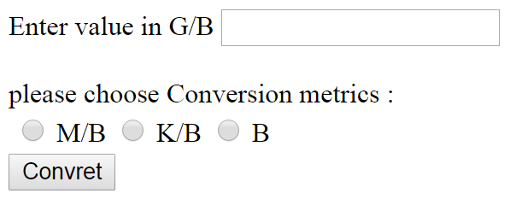

1. User must enter number value and choose conversion metric to convert the entered value to it.
2. Then user press “**Convert”** button.

You must create a managed bean called Conversionbean.java that contain two attributes one for the **entered number** and second for **chosen metric** and “**convert()”** method that can convert the entered number to the specified type.

When the user press the **“convert”** button, the conversion result must be displayed in another page called “**result.xhtml**”

You must do the following:

1. Validate the text filed to ensure that user enter a value if user does not enter a value you must display the following message **“you must enter a value”**.
2. Validate the text filed to ensure that the value user entered is a valid number if user does not enter a valid number you must display the following message **“you must enter a valid number, Letters and special characters not allowed”**.
3. Validate radio buttons to make sure that user has choose a conversion metrics; if user does not choose a metric you must display the following message **“you must choose the conversion metric”**.